Module 3

1. What are the four important <meta>tags we use in SEO?

* Tittle
* Description
* Keywords
* Robot tag (html tag)

1. What is the use of open-graph tags in a website?

* Open graph tags are snippets (schema markup & structured markup) of code that control how urls are displayed when shared on social media. We can find them in <head> section of the webpage and is tag with og:

1. What tag we will use to add an image to the website? Explain the points we should care about while adding the image to the website.

* We use atl-attribute/alternative text to add an image to the website.
* Original image,content relevant & compressed image, Mobile user friendly ,

1. What is the difference between NOFOLLOW and NOINDEX?

* Nofollow : it instructs the crawler not to follow the links on the page.
* Noindex : it instructs the search engine not to index the page.

1. Explain the types of queries.

* There are 3 types of queries :

1. Transactional queries: buy,sell,order,discount
2. Informational queries : users are looking for information eg : best villa in Udaipur.
3. Navigational queries : users searching for product by particular brand
4. What is the importance of Site Map and Robot.txt in SEO?

* Sitemap : A list of all the pages of our website & links that helps search engines crawl & index the most important content of our site.
* Robot.txt : it tells search engines which page to crawl & which to avoid.It specifies the location of the xml sitemap.

1. Below is the list of pages for an e-commerce site that doesn’t need to be crawled by any crawler.

o Admin pages o Cart page o Thank-you page o Images How will you achieve this?

* We will achieve this in robot.txt.
* We have to enter a code : User-agent*disallow/

1. What are on-page and off-page optimization?

* On-Page : The process of optimizing web pages by influencing internal factors like content quality,html source code, content structure,keyword density,meta tittle & description,page tittle,url structure,internal linking,sight speed.
* Off-page : it improves our website performance with the help of external factors like link building, blog directory submission,forum submissions,social bookmarking,social media engagement.

1. Perform an on-page SEO using available tools for [www.designer2developer.com](http://www.designer2developer.com)

* Keyword density : 9 times. It should be maximum 0.2%
* Plagarised content.It confuses google algorithms & results in non ranking of certain pages.Content should not be dublicate.
* Meta tittle : It should be 50-65 character.

IOT development company|Top Mobile App Development Company

* Meta description : It shoud be of 150-165 characters.

1. **Keyword Research**

|  |  |  |  |
| --- | --- | --- | --- |
| Sr.No | Keyword | Monthly average | Competition |
| 1 | designer to developer | 100-1k | Low | |
| 2 | iot development | 100-1k | low | |
| 3 | iot app development | 100-1k | low | |
| 4 | iot software development | 10-100 | low | |
| 5 | iot mobile app development | 10-100 | low | |
| 6 | Enterprise solution Development | 10-100 | low | |
| 7 | enterprise apps development | 100-1k | low | |
| 8 | Mobile app development company | 10k-100k | low | |

1. **Optimize Meta tags**

* **Tittle Tag** : **It should be between 50-65 characters**
* **Given in website** :IOT development company |Top Mobile App Development Company
* **Made by me** : Expert IOT Development Company ,Innovative IOT Solutions & services
* **Meta Description** : **It should be between 150-165 characters**
* **Given in website**:Leading android app development company ,iphone app development company,IOT product development company,Telematics Software Development Company ,Connected Car.
* **Made by me** : Expert IoT development services delivering innovative solutions to connect devices, streamline operations, and enhance user experiences with cutting-edge technology.

1. **URL Structure and Pages**

* About  [: https://www.designer2developer.com/#About](%20:%20https://www.designer2developer.com/#About)

Canonical : <https://www.designer2developer.com/>

* Expertise :[https://www.designer2developer.com/#EXPERTISE](https://www.designer2developer.com/" \l "EXPERTISE)
* Our Methodology:
* <https://www.designer2developer.com/#ENGAGEMENTMODELS>
* Projects : <https://www.designer2developer.com/mobile-and-web-application-development-company/>
* Contact : <https://www.designer2developer.com/contact-us/>

Note : In the above links they have mention special character ‘#’& capital letters.

Changes needed: avoid using special character in capital letters & numbers in urls.

1. **Header Tags**

* **H1 is missing . There must be 1 h1 tag for each single page that contains primary keywords.**
* **Eg :**

**H1 :** Innovative Digital Solutions: Custom Web, Mobile & IoT App Development"

1. What are the characteristics of “bad links”?

* Bad links are the low quality links that can harm our website reputation & search engine ranking. Here are few characteristics:

1. Irrelevant & low quality websites.
2. Spammy website
3. Dublicate anchor text
4. Excessive link exchange
5. Poorly written content
6. Perform Keyword Research then create a blog on “Importance of IT Training” and provide a link to TOPS Technologies and connect it with the webmaster and Google Analytics

|  |  |  |
| --- | --- | --- |
| KEYWORD RESEARCH | AVERAGE MONTHLY SALES | COMPETITION |
| IT training and consulting companies | 10 – 100 | Low |
| IT skill development training | 10 – 100 | Low |
| IT skills development | 100 – 1K | Low |
| IT training benefits | 10 – 100 | Low |

Blog link : https://ittrainingbenefits.blogspot.com/2024/09/it .html

Google search console :

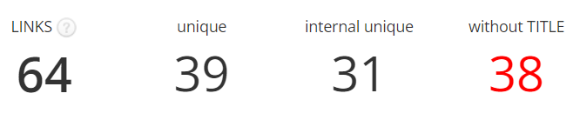

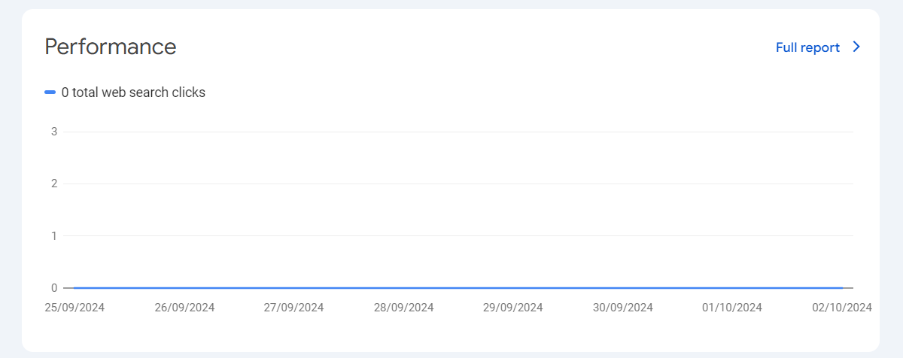 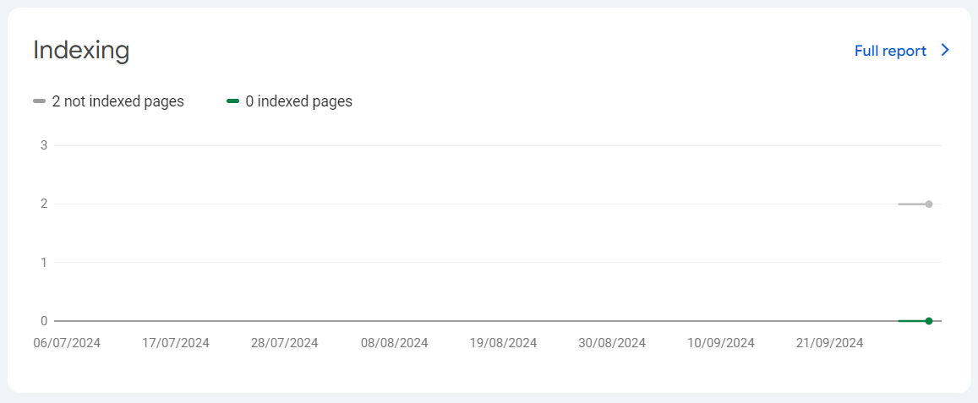

1. What is the use of Local SEO?

• **Increased Visibility in Local Searches**: When people search for products or services in their area, local SEO helps your business appear in the top search results, maps, or local listings, attracting local customers.

• **Targeting Local Audience**: It focuses on optimizing your website and online presence for a specific location, so it reaches potential customers who are nearby and more likely to visit or use your services.

• **Better Google Maps Ranking**: Local SEO helps businesses rank better on Google Maps, making it easier for users to find directions to your location.

• **Boost in Website Traffic**: Optimizing for local searches can drive more targeted traffic to your website, leading to higher conversions as local customers are often more ready to make a purchase.

• **Competitive Edge**: It helps small or local businesses compete effectively against larger, nationwide companies by focusing on local search queries and building a strong presence in the local area.

• **Enhances Reputation**: Local SEO often includes customer reviews and ratings. Positive reviews can enhance your business’s reputation and attract more customers.

3.1 3.2

